


Backend Development, 5cu
Study diary
Your name here

Lasanthi Ganewaththa Kankanamge

Contents
1 Week exercises 3
1.1 Written answers to questions 3
1.2 The first weekly exercises here, relevant code, explanations and screenshots (the same applies in following week exercises). 3
2 Week excercises 4
3 Week exercises 5
4 Week exercises 6
5 Week exercises 7
Sources used with exercises 8

Important general note for all weekly exercises: List all external sources you’ve used to implement the task (github, tutorialspoint, other projects, network sites, blogs etc..)

Week exercises

Written answers to questions
Exercise 01
- VSCode Overview
• Visual Studio Code (VSCode) is a free and lightweight code editor developed by Microsoft.
• It supports many programming languages, including JavaScript and Node.js.
• Debugging: You can set breakpoints, run the code, and inspect variables directly in VSCode.
• Extensions: VSCode allows installing extensions like Prettier, ESLint, and REST Client to improve development.
• Integrated Terminal: You can open a terminal inside VSCode to run commands (like `node app.js` or `npm start`) without switching windows.
• Version Control: Built-in Git support helps track code changes and commit updates easily
- Node.js and Express Basics
Node.js
• Node.js allows running JavaScript code outside the web browser.
• It is built on Chrome’s V8 JavaScript engine and is mainly used for backend/server-side programming.
• Unlike traditional web servers (like Apache), Node.js uses a single-threaded, event-driven model, which makes it faster for handling multiple requests.
• It is commonly used to create APIs and real-time applications like chat apps.

Express.js
• Express is a framework built on top of Node.js that makes web app and API development easier.
• It provides built-in features for routing, middleware, and handling HTTP requests/responses.
• Compared to Node’s built-in HTTP module, Express saves time and reduces code complexity.
• Express is popular because it is lightweight, easy to use, and has a large community.

- Extensions Overview
REST Client
• Allows developers to send and test HTTP requests (GET, POST, PUT, DELETE) directly inside VSCode.
• Helps test APIs without switching to an external tool like Postman.
• Displays the response (status code, headers, and body) inside the editor.

Prettier
• Automatically formats code to make it neat and consistent.
• Helps maintain a uniform code style across all developers in a project.
• You can configure Prettier in VSCode settings or by creating a `.prettierrc` configuration file.
• Commonly set to “Format on Save” for convenience.

ESLint
• Analyzes code and warns about potential errors or style issues.
• Helps catch mistakes like unused variables, missing semicolons, or wrong syntax.
• Enforces consistent coding rules and improves code quality.
• You can enable it in VSCode by installing the ESLint extension.

- Using Postman

• Postman is a standalone tool used for testing and debugging APIs.
• It lets you create and save requests, add headers, send data, and view responses in detail.
• Postman supports advanced features like environment variables, API collections, and automated testing.
• Difference from REST Client:
- REST Client works inside VSCode and is simpler for quick tests.
- Postman is an external app with more powerful features and a visual interface.
• Postman is very helpful for backend developers to test endpoints before connecting them to frontend apps.

Exercise 02
Creating a simple CRUD Application with Node + Express
Goal: Build a basic CRUD API to manage a Movie Collection.

Step-by-step (what I did):
1) Project Setup
- Initialized project: npm init -y
- Installed Express: npm install express
- (Optional) Installed nodemon for auto-reload: npm install --save-dev nodemon

2) Default data structure (in app.js)
const movies = [
{ id: 1, title: "Inception", director: "Christopher Nolan", year: 2010 },
{ id: 2, title: "The Matrix", director: "The Wachowskis", year: 1999 },
{ id: 3, title: "Parasite", director: "Bong Joon-ho", year: 2019 }
];

3) Routes created (in app.js)
- GET / : Returns an HTML page listing all movies
- GET /movies : Returns all movies in JSON
- GET /movies/:id : Returns a single movie by id
- POST /movies : Adds a new movie (expects JSON body with title, director, year)

4) How to run
- Start server: npm start (or npm run dev if using nodemon)
- Open in browser: http://localhost:3000/
- Test with REST Client (requests.http) or Postman

Code (app.js):
[See attached project zip or the app.js content pasted below]

// app.js (full content)
(see project zip)

Testing
- Tested the HTML list at /
- Tested GET /movies, GET /movies/1, and POST /movies using REST Client in VSCode

Exercise 03
Testing the API with REST Client and/or Postman
Goal: Practice using API testing tools to validate the CRUD endpoints created in Exercise 2.
What I did (summary):
• Kept the server running with node app.js.
• Installed the REST Client extension in VS Code.
• Created a requests.http file with requests for: GET /movies, GET /movies/:id, POST /movies, PUT /movies/:id, DELETE /movies/:id.
• Clicked “Send Request” for each block and confirmed correct status codes and JSON responses.
• Opened Postman Desktop and created a collection with the same five requests.
• Added sample data via POST (e.g., Interstellar), updated it with PUT, and deleted it with DELETE, verifying changes with GET.
Sample REST Client requests:
@base = http://localhost:3000

### GET all movies
GET {{base}}/movies

### GET one by id
GET {{base}}/movies/1

### POST add a movie
POST {{base}}/movies
Content-Type: application/json

{
"title": "Interstellar",
"director": "Christopher Nolan",
"year": 2014
}

### PUT update the movie (use the id returned from POST)
PUT {{base}}/movies/4
Content-Type: application/json

{
"title": "Interstellar (Updated)",
"year": 2015
}

### DELETE the movie
DELETE {{base}}/movies/4

The first weekly exercises here, relevant code, explanations and screenshots (the same applies in following week exercises).

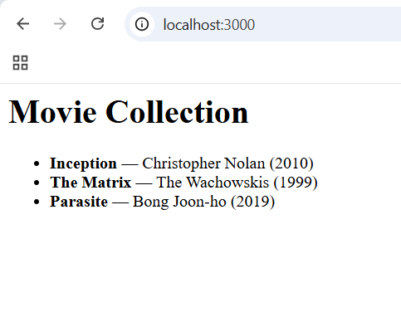

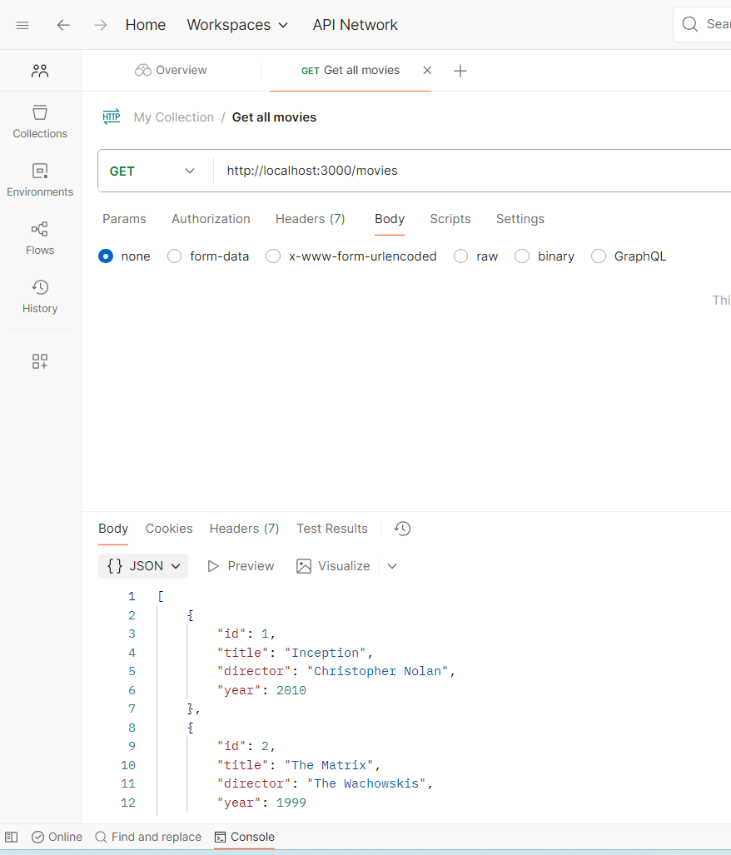

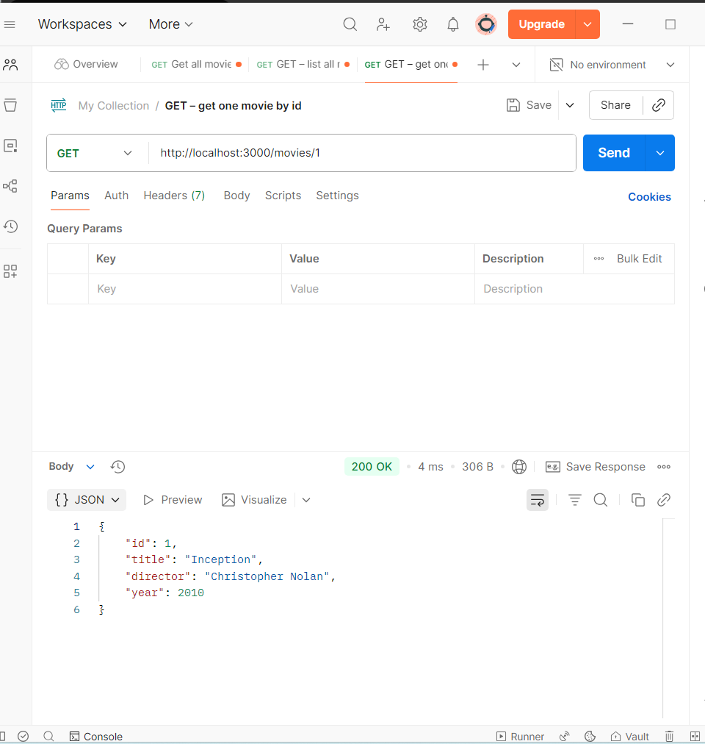

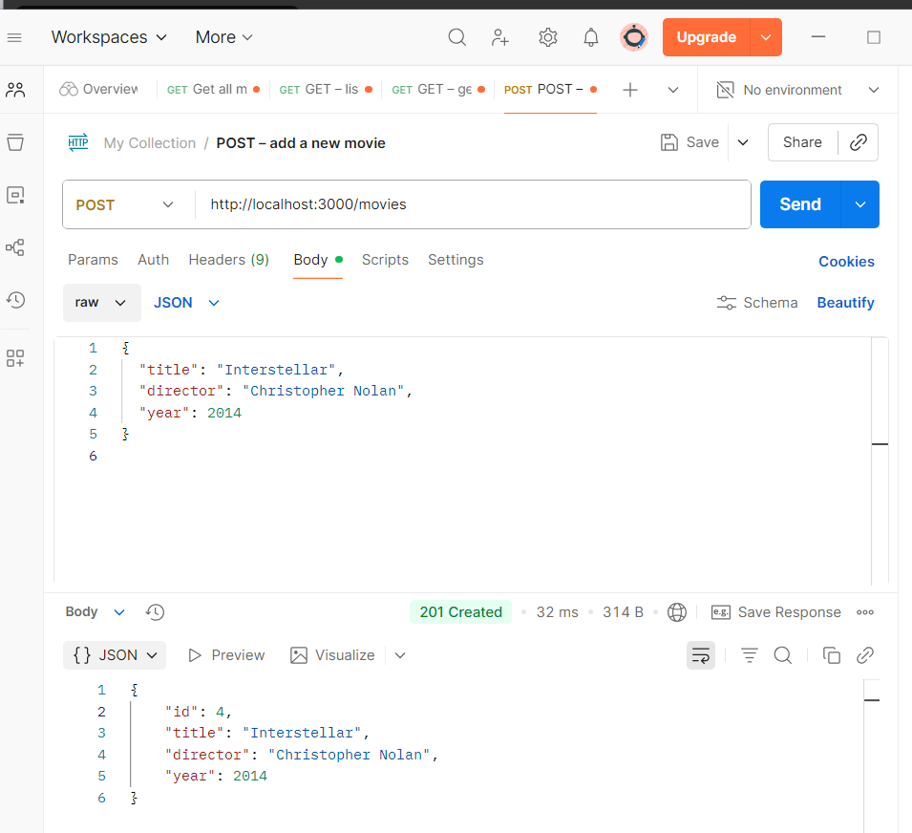

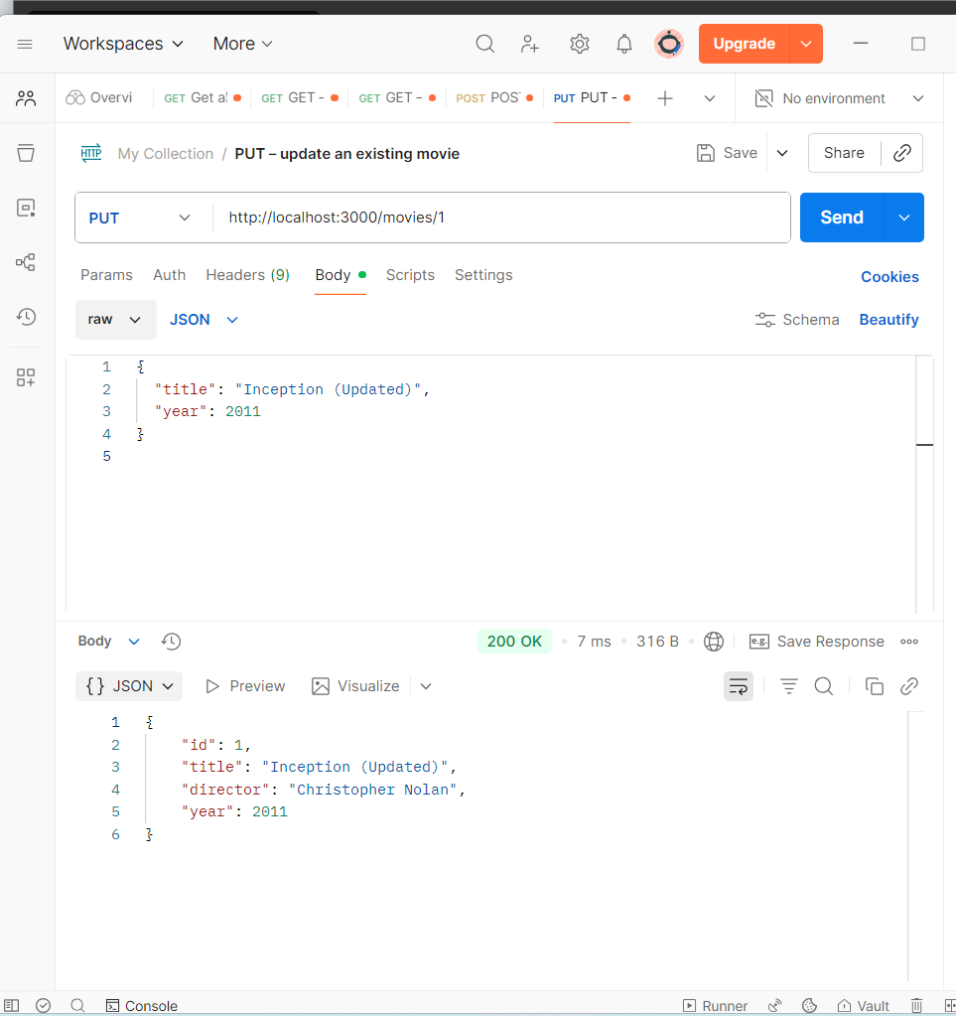

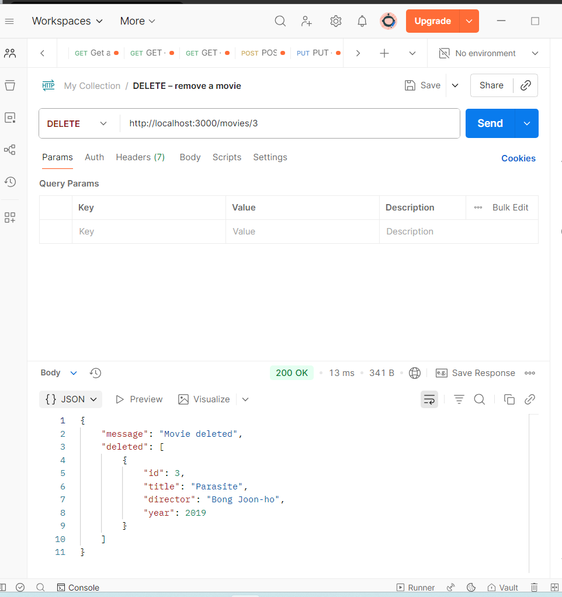

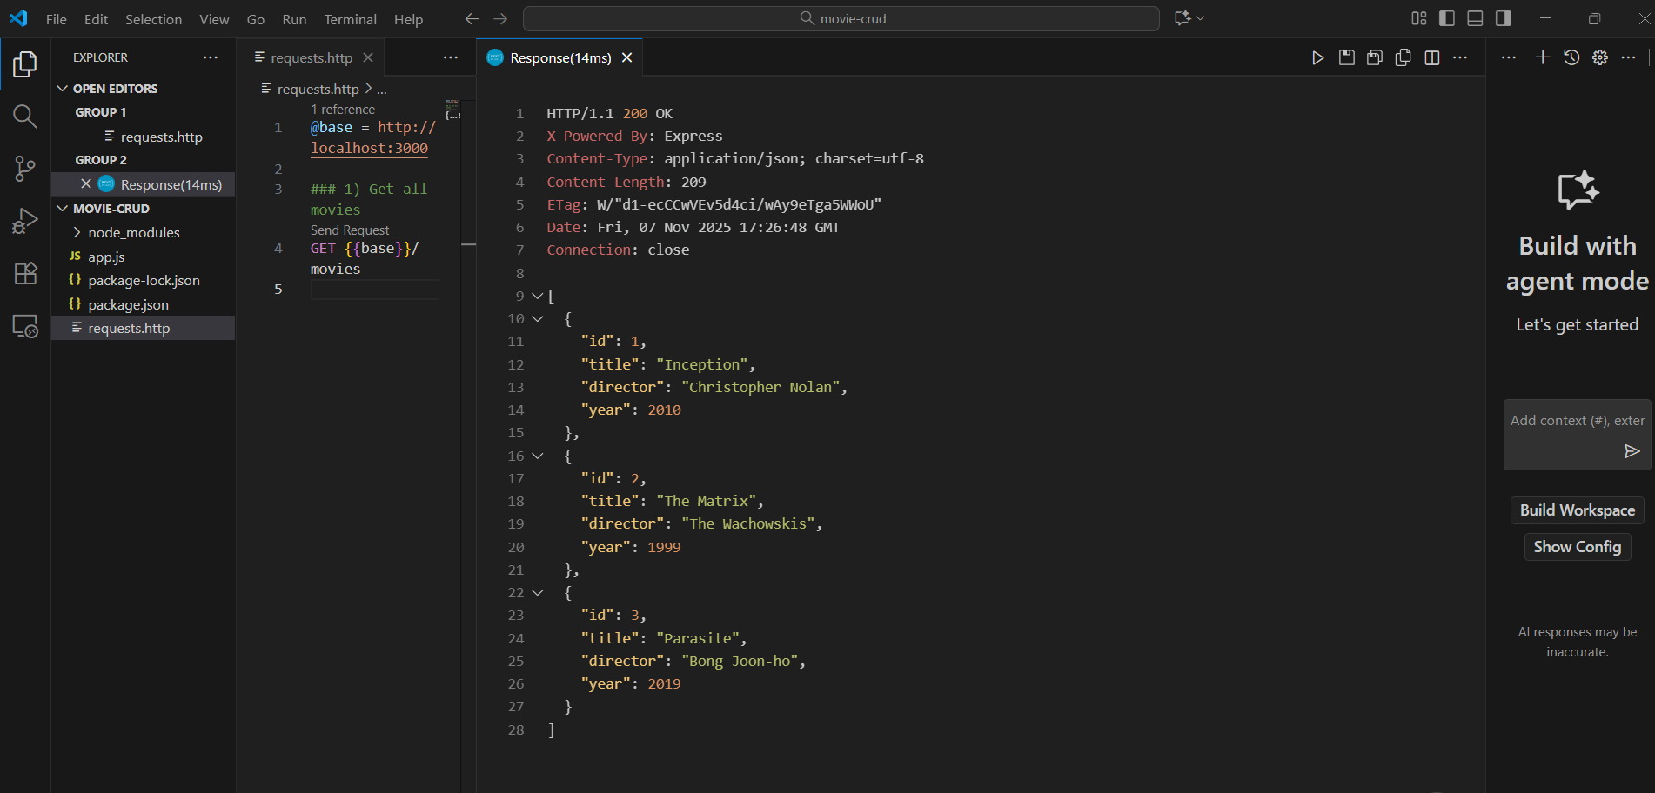

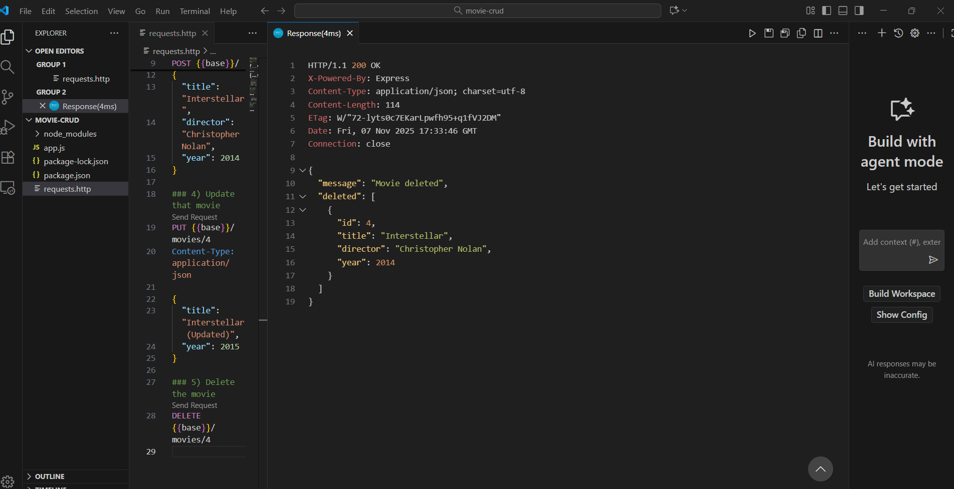

Sources Used (Week 1 / Exercises 1–3)

- Official Node.js documentation: https://nodejs.org/en/docs

- Official Express.js documentation: https://expressjs.com

- Visual Studio Code docs: https://code.visualstudio.com/docs

- Postman Learning Center: https://learning.postman.com

- REST Client (VS Code extension) GitHub page: https://github.com/Huachao/vscode-restclient

Example code snippets written and tested by me during the exercise.

Week excercises

Week exercises

Week exercises

Week exercises

Sources used with exercises
List here all sources you’ve used with exercises (e.g. stackoverflow, tutorialspoint, github etc.)

